

Risk Management Plan
Official Companion Artifact

This example shows the operating workflow for information security risk management at Arcfield. It connects risk criteria, scenario identification, assessment, treatment, residual-risk approval, evidence tracking and management reporting so that the risk process is auditable end to end. This is the operating method sampled on the 11 September 2026 freeze during the surveillance cycle after certificate ARC-ISMS (Information Security Management System)-2025-001.
Field | Value
Organization | Arcfield
Version | 1.1
Classification | Internal

Document Control
Field | Value
Organization | Arcfield
Version | 1.1
Status | Approved
Owner | Risk Manager
Approver | Top Management
Classification | Internal
Effective Date | 2026-09-11
Next Review Date | 2027-09-11

Revision history
A published change is a new row. Do not edit an approved version in place.
Version | Date | Change | Approved by
1.0 | 2026-08-29 | Initial Arcfield Platform publication. | Top Management
1.1 | 2026-09-11 | Approved Arcfield worked example after the 11 September 2026 internal audit. | Top Management

Legal Disclaimer
This companion artifact is provided for implementation support and does not constitute legal advice. Validate all controls, evidence and records against your organisation, scope, risk context and applicable requirements.
© 2026. MessemerTech OÜ. ExportableProof is an imprint of MessemerTech. All rights reserved.

Table of Contents

What this procedure is
Scope
Terms used here
Process overview
Procedure steps
1. Confirm scope, context, criteria and review population. (RMP-STEP-001)
2. Identify new or changed information security risk scenarios. (RMP-STEP-002)
3. Assess likelihood, impact and inherent risk. (RMP-STEP-003)
4. Select treatment option and assign treatment owner. (RMP-STEP-004)
5. Map treatments to controls and update Statement of Applicability. (RMP-STEP-005)
6. Review and accept or reject residual risk. (RMP-STEP-006)
7. Report high risks, overdue treatments and accepted residual risks. (RMP-STEP-007)
Roles and responsibilities
Evidence and records
Review and decision
References
Linked documents
External references

Instructions
Copy this file as the controlled Word master for your ISMS. The Arcfield identity fields on the cover are the approved worked example. Complete the steps below when you adopt the file for your organization.
- Fill the cover identity fields (Organization, Version, Classification, Owner, Approver, Effective Date and Next Review Date) when you adopt this file. The Arcfield values shown here are the approved worked example.
- Issue your own version and a new Revision history row. Do not edit an approved version in place.
- Cite this approved version from related records. Do not copy this file into those records.

Hint: Keep risk workflow evidence-linked: every assessed risk needs owner, treatment decision, residual risk and review evidence.
Book reference: Building the ISMS, Information Security Policies & Risk Management

What this procedure is
This document is Arcfield's Risk Management Plan. Define the information security risk management approach, scope, roles, methodology, risk appetite, treatment process, review cadence and reporting model. It is not the policy that sets the rule or the register that stores the live rows. This procedure applies to the Arcfield Platform (B2B SaaS (Software as a Service) for regulated fintech and health customers): production, customer data, CI/CD (Continuous Integration / Continuous Delivery), privileged access and critical suppliers. Neighbouring records (RR (Risk Register), ISO (International Organization for Standardization), ROAR) cite this Document Control version. Do not copy these paragraphs into them.

Scope
Use this table before you copy a rule into another record or exclude a duty from this file.
In this procedure | Not in this procedure
The rules, roles, worked Arcfield example and the records this file owns. | The ISMS boundary (ISS), Annex A selection (SoA) or live rows in RR, ISO, ROAR.
Interfaces that must cite this Document Control version, including CI/CD, identity and suppliers where they affect CIA. | Live ISS scope rows, SoA applicability decisions, or neighbouring live registers. Those files keep their own approved versions; this file does not duplicate them.

Terms used here
These terms are local to this file. Expand every acronym on first use in the body.
Term | Meaning
Owner | The named role that can be called in an audit for an outcome. A team name is not an owner.
Exception | A time-bound, approved departure with expiry and a compensating control.
CIA | Confidentiality, Integrity and Availability of in-scope information and services.
Document Control version | The approved version cited from neighbouring records. Do not copy this body into those records.

Process overview

Hint: The schema should show how risks move from identification to treatment, acceptance and reporting.
Book reference: Building the ISMS, Information Security Policies & Risk Management
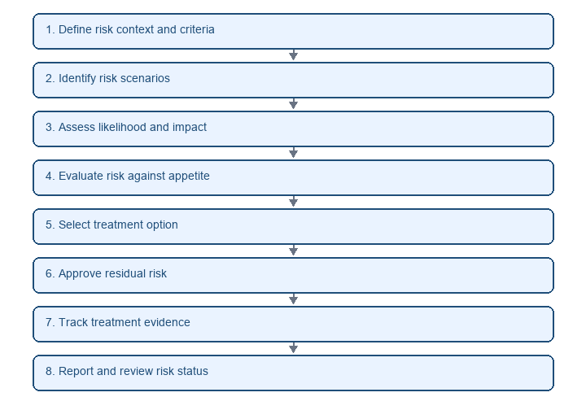

Procedure steps

Hint: Each workflow step should create or update a risk record, treatment record, decision record or reporting input.
Book reference: Building the ISMS, Information Security Policies & Risk Management

1. Confirm scope, context, criteria and review population. (RMP-STEP-001)
When: Quarterly risk review or material change
Who: Risk Manager
Input: Context changes, asset updates and interested-party requirements
Output: Risk review scope
Evidence: RMP-SCOPE-2026-Q3

2. Identify new or changed information security risk scenarios. (RMP-STEP-002)
When: Review scope confirmed
Who: Risk Owner
Input: Asset inventory, incidents, supplier changes and vulnerability results
Output: Updated risk scenarios
Evidence: RR-2026-Q3

3. Assess likelihood, impact and inherent risk. (RMP-STEP-003)
When: Risk scenarios updated
Who: Risk Manager
Input: Risk methodology and risk scenario details
Output: Assessed risk register
Evidence: RR-2026-Q3

4. Select treatment option and assign treatment owner. (RMP-STEP-004)
When: Risk assessment complete
Who: Risk Owner
Input: Assessed risk and acceptance criteria
Output: Risk treatment plan update
Evidence: RTP (Risk Treatment Plan)-REVIEW-2026-Q3

5. Map treatments to controls and update Statement of Applicability. (RMP-STEP-005)
When: Treatment plan updated
Who: ISMS Manager
Input: Treatment plan and control selection rationale
Output: Updated SoA (Statement of Applicability) coverage
Evidence: SOA-FULL-93-2026

6. Review and accept or reject residual risk. (RMP-STEP-006)
When: Residual risks require decision
Who: Top Management
Input: Residual risk summary and treatment evidence
Output: Residual risk decision
Evidence: ROAR-REVIEW-2026-Q3

7. Report high risks, overdue treatments and accepted residual risks. (RMP-STEP-007)
When: Quarterly reporting cycle
Who: Risk Manager
Input: Risk register, treatment plan and KRI (Key Risk Indicator) results
Output: Management review risk input
Evidence: MME-REVIEW-2026-08

Roles and responsibilities
Role | Responsibility
Top Management | Approves risk criteria and accepts significant residual risks.
Risk Manager | Operates the risk workflow and maintains methodology, reporting and review cadence.
Risk Owner | Owns risk assessment input, treatment decision and residual-risk acceptance proposal.
Control Owner | Implements assigned controls and provides treatment evidence.
ISMS Manager | Ensures risk treatment and SoA alignment.

Evidence and records
Related records live in the companion documents named below. This file cites them by their approved version. It does not copy their content. The Owner named on the cover is accountable for those live records.
- Mandatory Documents and Records Register — The 27 mandatory ISO 27001 documents and records, with owner, required status, approval, review cadence, location and evidence readiness.
- Document Register — Controlled documented information: origin, owner, approver, version, review cycle, retention and location.
- Records Retention Schedule — Retention rules for ISMS, security, privacy, audit and operational records, with owner, period, disposal method and evidence.

Review and decision
Field | Value
Decision | Risk workflow approved for Q3 operation with management follow-up on residual supplier and access risks.
Risks reviewed | 18
High risks | 3
Treatments overdue | 1
Residual risks accepted | 2
Open actions | 3
Reviewed by | Risk Manager
Decision date | 2026-08-29
Evidence reference | RMP-REVIEW-2026-Q3

References

Linked documents
These companion files sit next to this document in the unpacked package. This file cites them by their approved version. It does not copy their content.
- MDR Mandatory Documents and Records Register — The 27 mandatory ISO 27001 documents and records, with owner, required status, approval, review cadence, location and evidence readiness.
- DR Document Register — Controlled documented information: origin, owner, approver, version, review cycle, retention and location.
- RRS Records Retention Schedule — Retention rules for ISMS, security, privacy, audit and operational records, with owner, period, disposal method and evidence.
- RR Risk Register (Building the ISMS, Planning, Risk & Objectives (Clause 6)) — Interface record. Cite this Document Control version; do not copy this file into that record.
- ROAR ISMS Risks and Opportunities Register (Implementation & Certification, Asset Management & Information Classification) — Interface record. Cite this Document Control version; do not copy this file into that record.
- RTP Risk Treatment Plan (Implementation & Certification, Risk Assessment & Risk Treatment Process) — Interface record. Cite this Document Control version; do not copy this file into that record.
- MME Monitoring and Measurement Evidence (Implementation & Certification, Monitoring, Measurement & Performance Metrics) — Interface record. Cite this Document Control version; do not copy this file into that record.

External references
Cite these ISO clauses and book chapters from workshops and audits.
- ISO/IEC 27001:2022 — Normative ISMS requirements this companion artifact supports.
- Building the ISMS, Information Security Policies & Risk Management — Primary operating chapter for this companion artifact.
- Building the ISMS, Information Security Policies & Risk Management — Primary operating chapter for this companion artifact.
- Building the ISMS, Planning, Risk & Objectives (Clause 6) — Documented information, review and version discipline.

